## horizontal line

Final Project Documentation

Jayden Godbold

**─**

# Features

# Home Page

# 

* + Home Screen -
    - Contains multiple collection views inside a table view.
    - Each cell has its own information parsed from the movie database API and displayed as one cohesive package.
    - When tapped the user is brought to a new screen where they can view a trailer streamed from youtube and read a description of the movie. (favorite button does not work here)
    - When 3d touch/long-press is utilized, the user can favorite the move and it will appear in the favorites section
    - When the user scrolls the app bar fades away with the scroll view so only movie tiles are visible

# Search Page

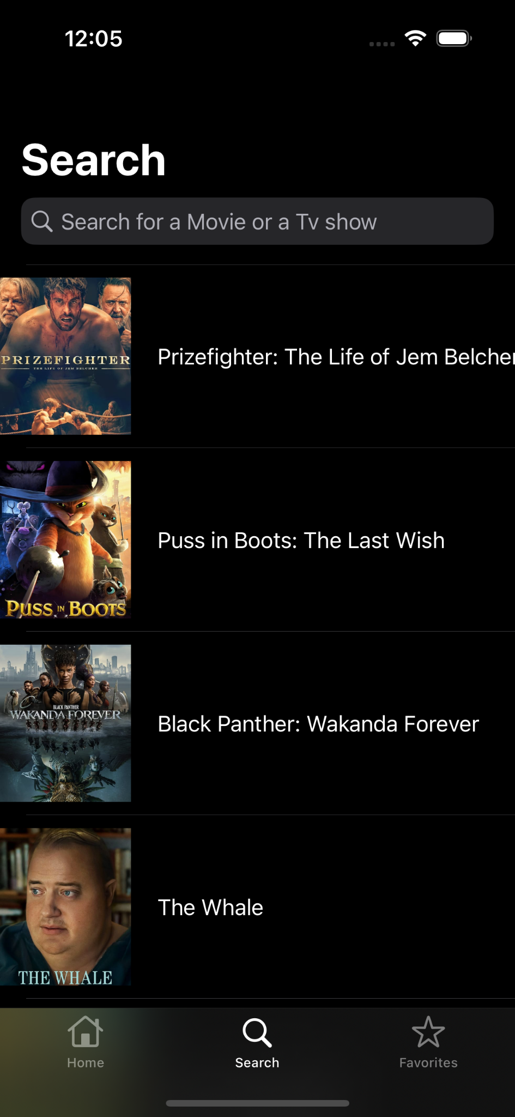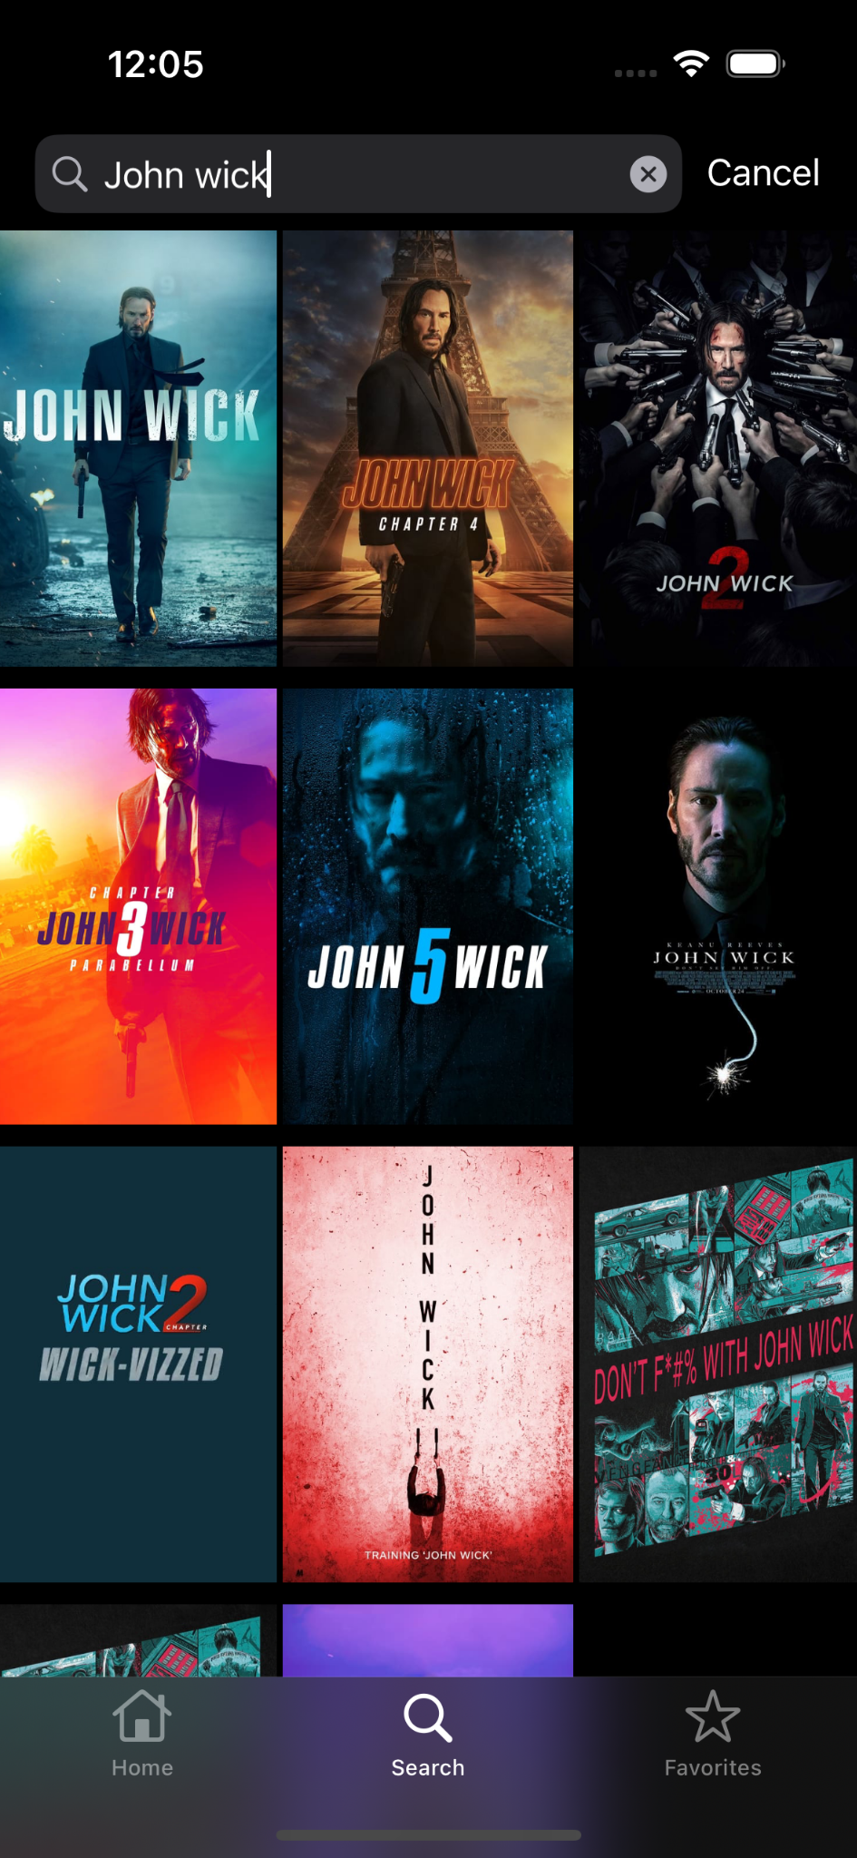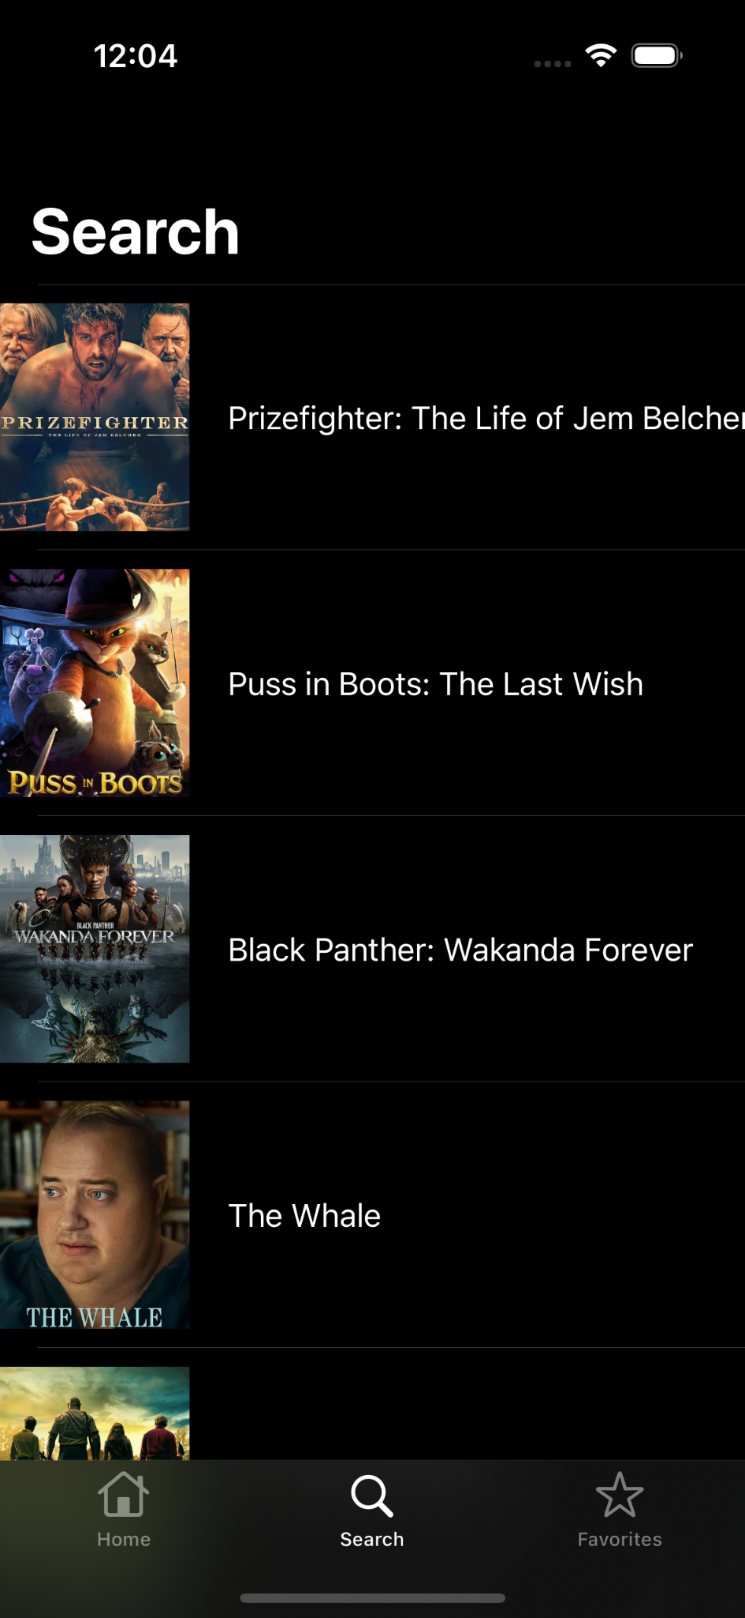

# 

# 

# 

# 

# 

* + Search Screen
    - Initializes with a hidden search bar, when pulled down the search bar appears and you can search for any move that you want. This screen is its own view controller class and displays movies in a three-tile format down the scroll-view
    - Contains a table view that contains cells of movies, when tapped they are redirected to a new screen where they can view a trailer streamed from youtube and read a description of the movie. (favorite button does not work here)
    - When the user scrolls the app bar fades to the top of the screen where the “Search” title minimizes to a smaller version with the scroll view so only movie tiles are visible

# Favorites Page

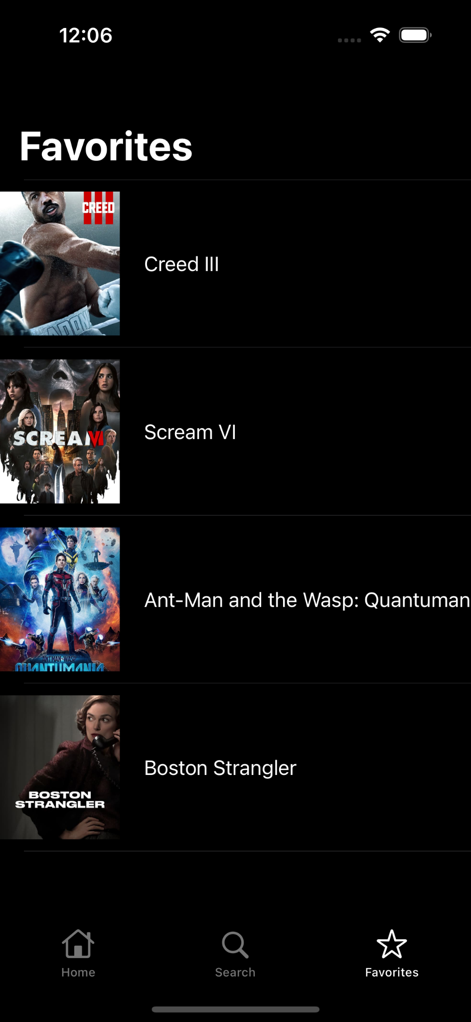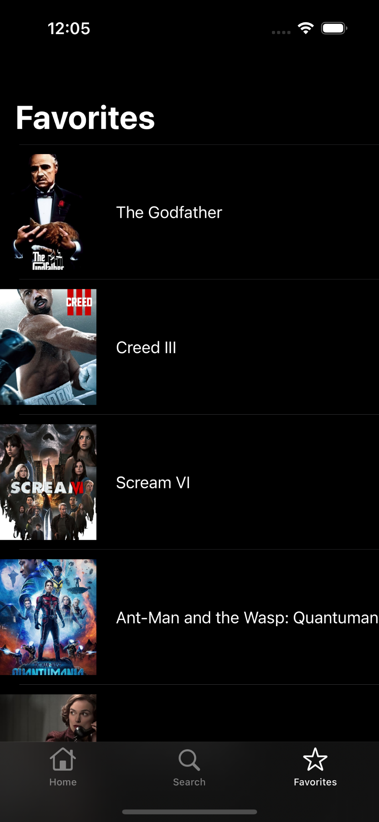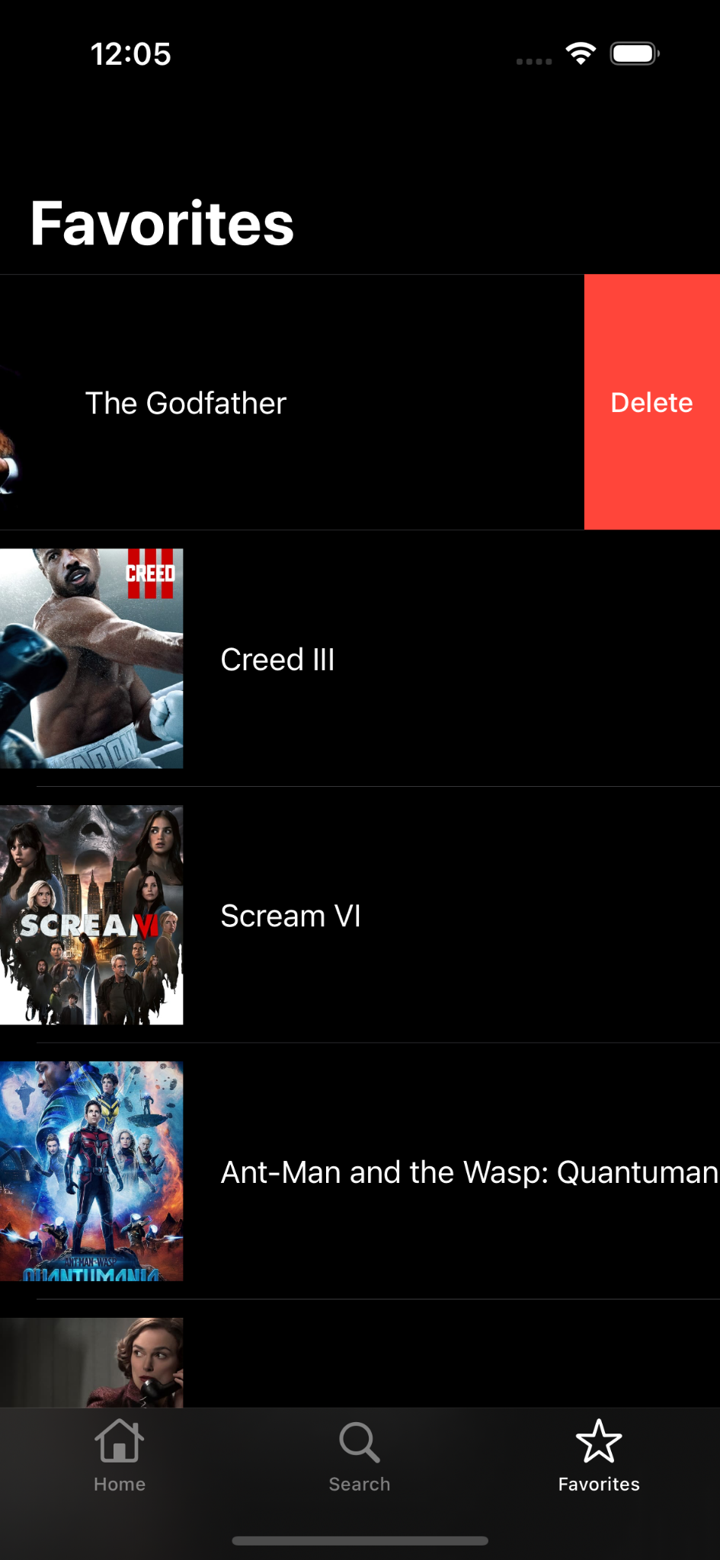

* + Favorites screen
    - Contains a table view that contains cells of movies, when tapped they are redirected to a new screen where they can view a trailer streamed from youtube and read a description of the movie. (favorite button does not work here)
    - When the user scrolls the app bar fades to the top of the screen where the “Favorites” title minimizes to a smaller version with the scroll view so only movie tiles are visible
    - When there is a favorite movie present, it is removable via gesture control, if the user swipes to the left they have the option to remove the movie tile from their favorites.

# Api Documentation

* <https://developer.imdb.com/>
* <https://developers.google.com/youtube/v3/docs>
* <https://sdwebimage.github.io/>